**Retraining inception v3**

Pre requisites:

* Python
* tensorflow (1.4)

1. Just download <https://github.com/tensorflow/tensorflow>
2. Extract where you want to, in my case D:\tensorflow-master
3. This is the core directory where we will be working D:\tensorflow-master\tensorflow\examples\image_retraining
4. I referred to this link <https://stackoverflow.com/a/45126137/6833276>
5. Go to D:\tensorflow-master\tensorflow\examples\image_retraining and then run the below code
   1. python retrain.py --**image_dir**=path\to\dir\where\flowers\images\where\extracted **--output_lables**=retrained_labels.txt **--output_graph**=retrained_graph.pb
   2. **–image_dir** 🡺 Show your image directory

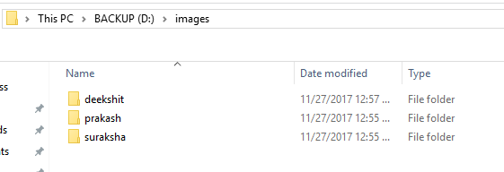

* 1. **–output_lables**🡺 Show where you want to store your labels.txt (in my case it made a separate folder and placed it there even though I had given a path for it to store It made its own output_labels.txt)
  2. **–output_graph**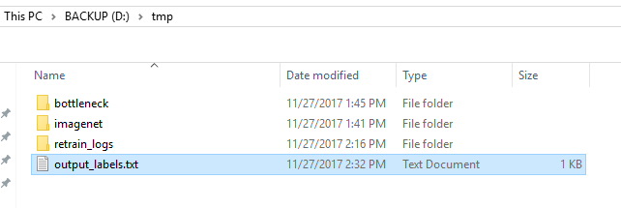

1. After running the code in cmd prompt (After successful retraining)you should get this

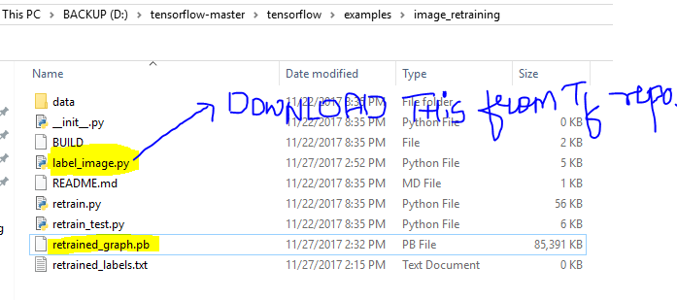

Download this from Tensorflow repo (Select branch corresponding to your tensorflow version in my case its 1.4 in his case it was 1.2 I copied label_image.py code and placed in above as shown)

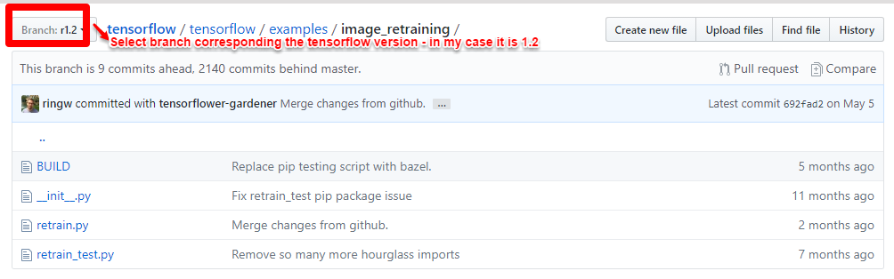

1. Now get some test image and try



1. python label_image.py --graph=D:\tensorflow-master\tensorflow\examples\image_retraining\retrained_graph.pb --labels=D:\tmp\output_labels.txt --image=D:\faces\b.jpg